How To Dual Boot on your MOE Restricted PLD

  - Disclaimer: This is only for those who understand the risks involved and the consequences that come with them. This is not to be shown to ANY MOE Staff (teachers, school ICT, admins, etc…).

  - Risks: Accidentally wiping your whole drive with no way back, murdering your PLD, etc...

  - Firstly, what is dual booting? Dual booting is having 2 Windows Operating System on one Hard Drive. So, in our case we will have one restricted Windows, and one unrestricted Windows. Why can’t I just have unrestricted Windows? This is because MOE can see when you are active. If they find you inactive for a long period of time, they will get suspicious and report to the school. Then you are finished. Enough details, let me show you how you can do it.

  - This process takes around 1-2 hours depending on your laptop.

  - Method 1: (if you have 2 USB Drives that have at least 8GB of storage)

  - What you will need:
- USB Keyboard
- USB Drive (at least 8GB storage)
- Your personal computer (which you have full access to)
- USB Mouse
- The guts to do it

Step 1: Getting the required files

  - Since we are so generous we will put the files here in this Google Drive Link. Please install all of them before you move on to Step 2.

https://drive.google.com/drive/folders/1E9UX6T6z2kYlhPpbEVhP1luL4X-G365o?usp=sharing

  - Now depending on your brand of laptop click on one of the links that match your brand:

  - Acer: https://www.acer.com/sg-en/support/drivers-and-manuals
  - Lenovo: https://pcsupport.lenovo.com/us/en/products/desktops-and-all-in-ones/lenovo-c-series-all-in-ones/lenovo-c560-all-in-one/downloads
  - HP: https://support.hp.com/sg-en/drivers/laptops
  - The serial number is on the back of your PLD. It’s the one that says S/N: **********************

  - Scroll down and install any version of WIRELESS LAN Drivers. Then, plugin your 2nd USB Drive and extract the driver to the USB.

Step 2: Setting Up
  - Note: You are not able to use your keyboard or trackpad during the setup phases
  - Now plugin your USB Drive. Open Rufus and just complete the installation process.

  - Things may get a bit difficult to understand so stay with me.
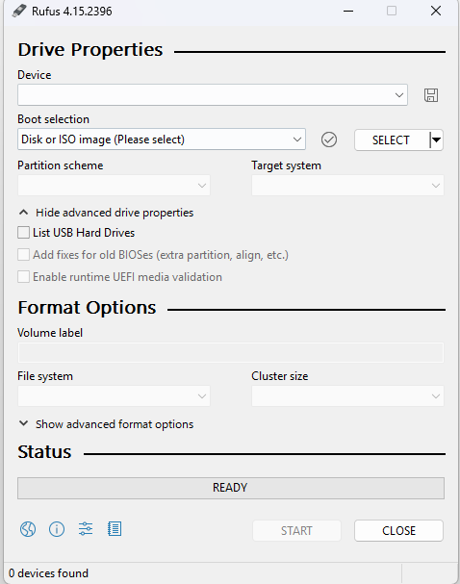

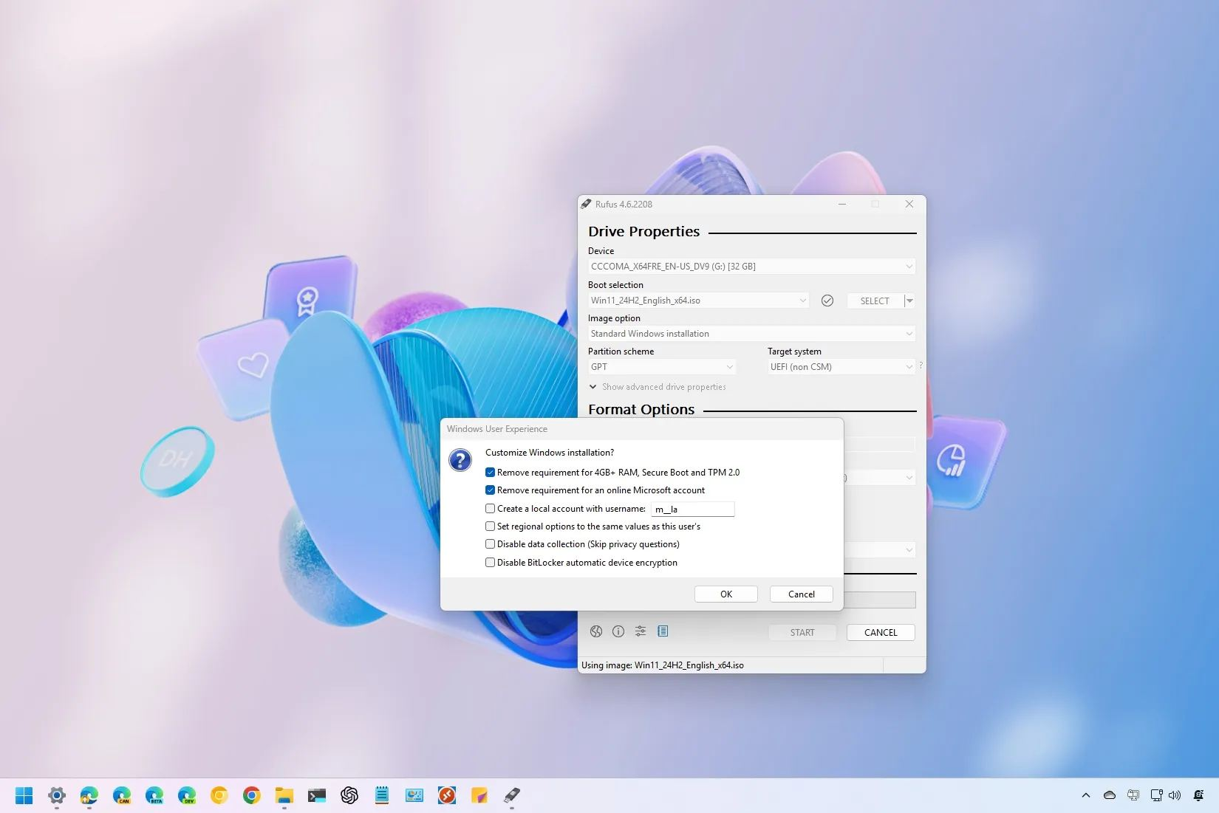
  - Make sure you are this page. Now under device make sure that your USB Drive is selected. Make sure that boot selection is Disk or ISO Image. Press the SELECT button and select your Windows.iso file that you installed from Google Drive. Press Start.

  - Now select only the 1st and last options and the last option as well. Press OK. It will take some time to install.

Step 3: The Fun Begins…

  - Once your RUFUS is finished installing the file onto your drive, get your PLD. Turn it on and sign into your account. Now press restart while holding the shift button. While your PLD is restarting plugin your USB drive that you installed Windows on.
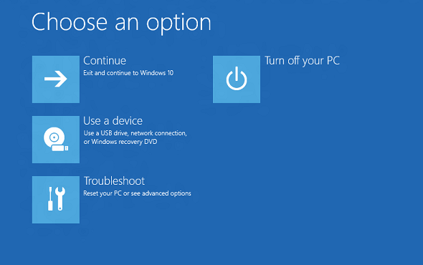

  - Now on your PLD, Click troubleshoot.
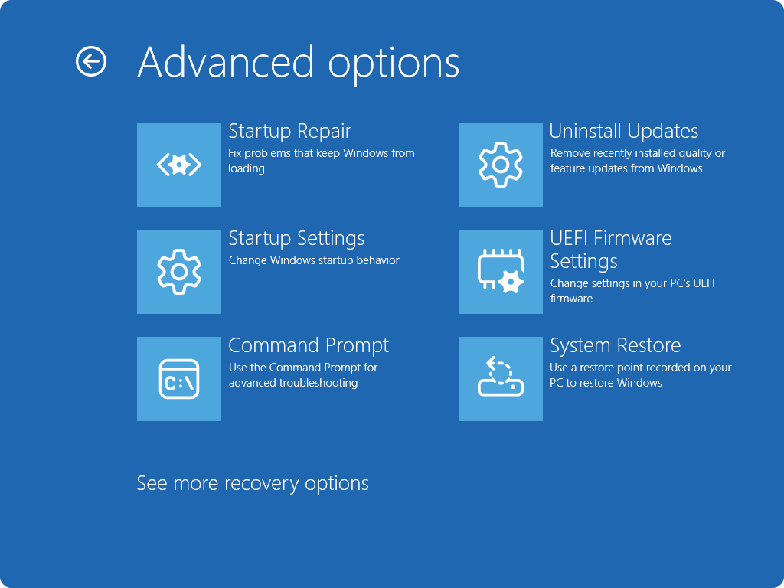

  - Now click UEFI Firmware Settings and press restart.
  - Now your PLD will restart and enter the BIOS.

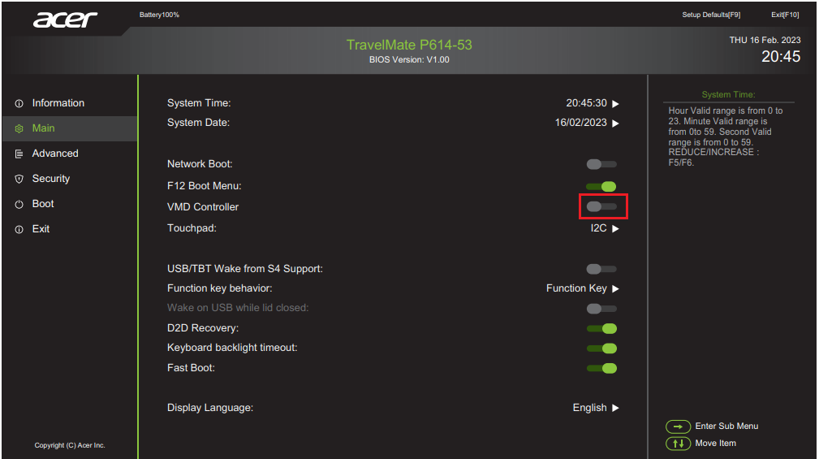

  - Navigate to Boot. (I am using ACER so the BIOS will not be the same for all)

  - Now you will see 2 options to boot from.

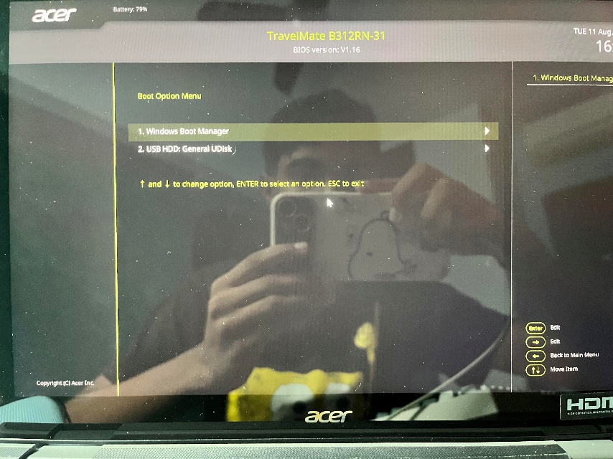

  - USB something something… and windows boot manager. Now select USB… and press F6. This next step is crucial. Turn off the Secure Boot option. Now find the exit option and exit saving changes.

Step 4: There’s No Turning Back Now

  - Now after some time you will see this:
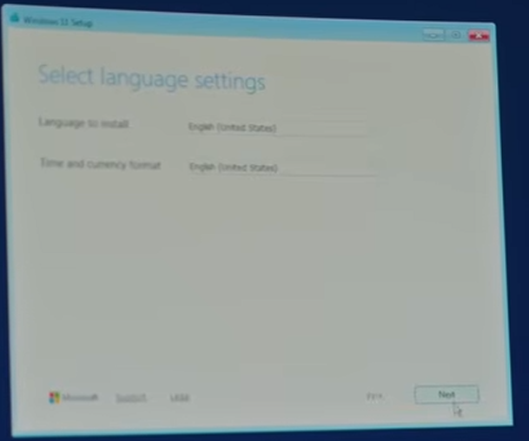

  - You will only be able to use a USB mouse or USB Keyboard (if you have). Now, get them and connect them.

  - Press Next. Now you will see select setup option. Make sure that Install Windows is chosen and press agree. And go next.
  - Just accept everything until you end up at this page:

  - THIS PART IS VERY IMPORTANT SO PAY ATTENTION.

  - Click on the partition that says Primary under type and double-check that you are deleting the right one and press the delete button either on your USB Keyboard or the delete partition option at the top of the page.

  - After you have deleted the partition, it will show up as Unallocated Space. Select it and go to the top and press add partition. Add how much ever you want for your DMA Windows.

  - Press Next after selecting the larger unallocated space.

Step 5: The First Success

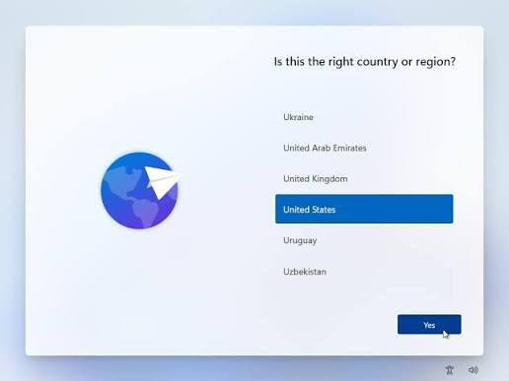

  - Now you will see this after you have successfully entered the Windows Setup Phase. You can remove the USB Drive that you used to install Windows. Just choose the country applicable to you and press yes.

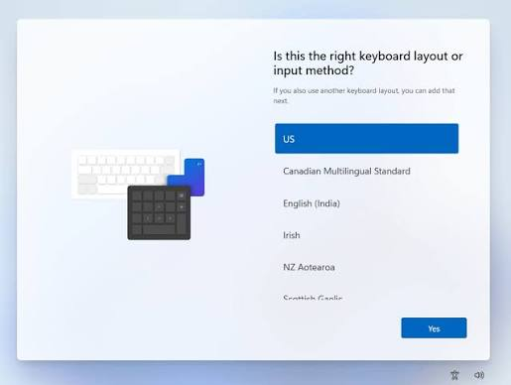

  - Now on this page, select the keyboard layout you prefer. (US – QWERTY). Press Yes.
  - It will ask you if you want a second keyboard layout. Wait. Now press the accessibility button and the right-bottom corner if you don’t have a USB Keyboard. (The thing that looks like a man raising his hands). Switch on the on-screen keyboard. A digital keyboard will now pop up. Now you can press the blue skip button and move on.

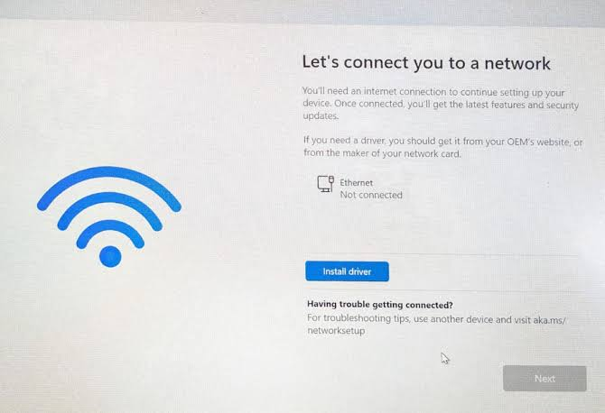

  - Now you will be on the network connection page. Now, you have to plugin the other USB Drive which you uploaded the drivers onto.
  - Click install driver on the network connection page and select the WIRELSS LAN folder from your USB Drive. After a while you will be able to connect to internet.
  - Note: If you are doing this in school try to avoid using school Wi-FI. Instead, if possible, get your friend to turn on hotspot on their PLD and connect to that instead. If you aren’t using a USB Keyboard, use the digital keyboard and type the password by using the mouse to click.
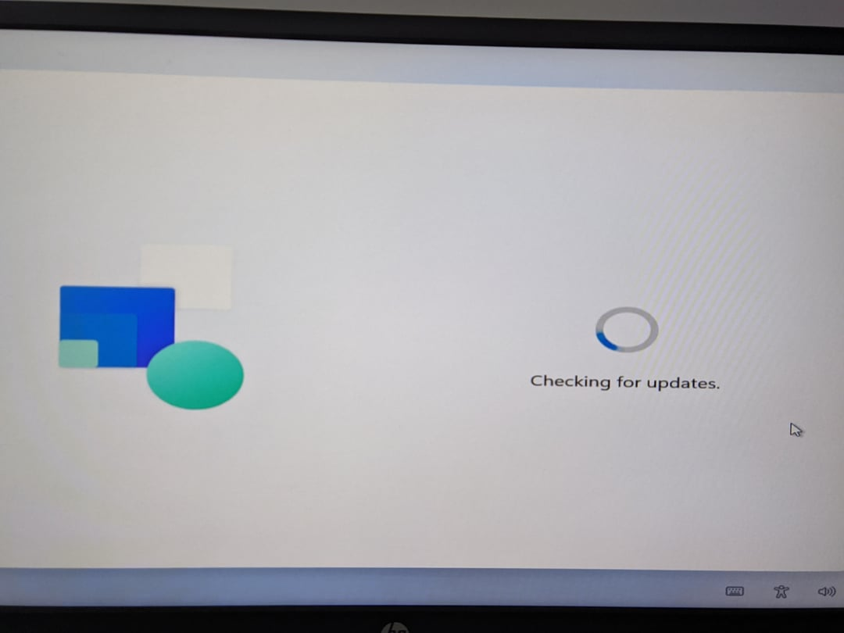

  - Now you have to be patient (again :>).

  - After some time (and lots of installing), you will finally get to the sign-in page. Now use your keyboard and press Shift + F10. You will see the command prompt. Now type ‘ms-cxh:localonly’ and press enter you will see a window that says setup local account. Now finish all the steps and press next. After some time, you will finally have your unrestricted windows

  - Now just go to settings and go to update and let it update so that you can use your keyboard and trackpad and all the stuff like normal just that you have your own account.

Step 6: Setting up DMA Windows

  - Now plugin the USB Drive you installed Windows onto and repeat steps 3 – 5.

  - Now once you are at the sign-in page, sign-in to your MIMS Account (school account). Now you will be in your DMA Windows. Now go to settings and got updates and wait for until you can use your keyboard and trackpad. Then go to accounts in settings. Then go to work and school. Then go to the dropdown under work or school account and press info then scroll down and press sync now wait patiently until you get Chrome installed.

Step 7: Learning How to Boot into Each OS

  - Now restart your PLD. And you will see choose an operating system this is where you will choose which Windows you wanna choose. Now just test one and see where you go then you will know. Well that’s about it.

Conclusion

  - Congrats! You have successfully dual-booted!

Credits

- Students of Singapore
- RRPLD

